CALL FOR PAPERS
WISPS XXII Annual Conference
University of Leicester and online, 10th and 11th November 2022
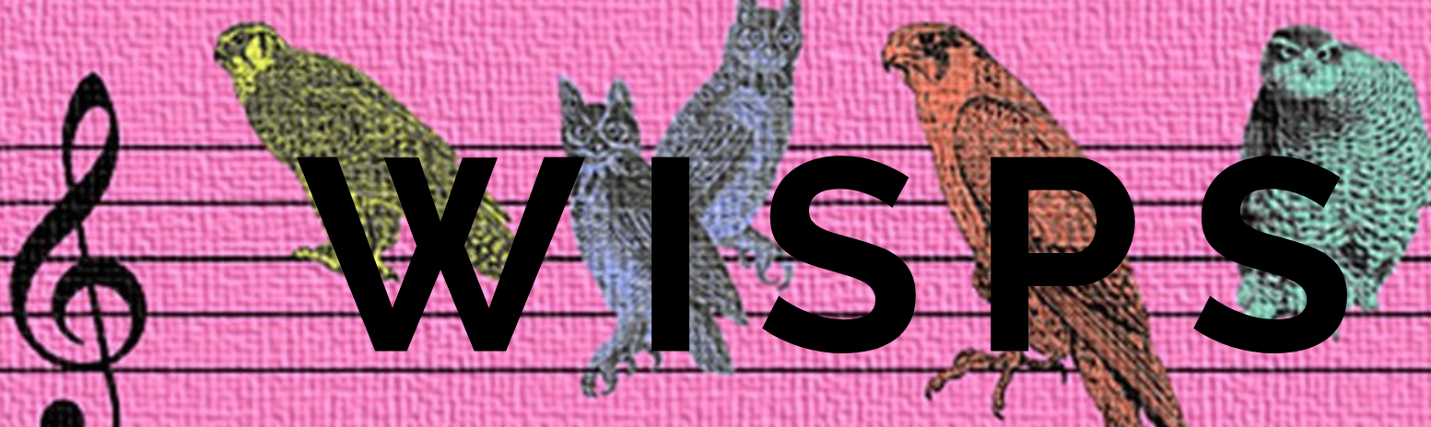

Keynote speaker Dr Lesley Wylie (University of Leicester)
A roundtable discussion with the visual artist Sofia Yala

We would like to invite academics conducting research into Luso-Hispanic Studies to join us at the WISPS XXII Annual Conference in a partly hybrid format. On the 10h of November, the conference will be online and on the 11th of November, it will take place at the University of Leicester.

We welcome proposals from members or friends of WISPS and people of all genders as well as postgraduate students in the fields of feminist theory, history, linguistics, literature, cultural and textual theory, audio and film studies, performance studies, politics, anthropology, geography, queer theory, and theatre studies relating to any of the cultures of Spain, Latin America and the Lusophone world.

We invite 200-word proposals for individual papers of 20 minutes or panels, consisting of three papers of 20 minutes. We also welcome proposals for workshops and roundtables. In WISPS we are especially interested in cross-disciplinary and inter-disciplinary work. For panels, the panel convenor should send 200-word abstracts for the three papers.

Please send your individual proposal via https://forms.gle/SSTk3r4aJuPBDxis8 or panel proposal via https://forms.gle/MgA34MBCQThGbTjr6 by 31st July 2022. You will receive an acknowledgment of your submission within five working days. If this does not happen, please contact the Conference Secretary.

Three postgraduate travel bursaries of up to £175 (€195) each will be available for members of WISPS and bursary holders will not pay for conference registration. If you are a postgraduate student and want to apply for our travel bursaries, please send a CV, a detailed breakdown of anticipated costs and a short personal statement – indicating why you want to attend WISPS, how this conference will benefit your academic career, and if you are in receipt of funding from another funding body – together with your abstract to wispsleicester2022@gmail.com

Details about the conference registration will be circulated in due course. For any queries, please contact the Conference Secretary Dr Lourdes Parra Lazcano at lourdes.parralazcano@abdn.ac.uk and Dr Maite Usoz de la Fuente at mudlf1@le.ac.uk
Practical information about the conference will be made available on https://www.wispsacademic.org/
WISPS XXII Annual Conference is sponsored by:

